VPC
1 . Create VPC with 2 private and 2 public subnets.
- Login to aws console
- Search for VPC
- Click create vpc
- Select vpc
- Give CIDR range

- 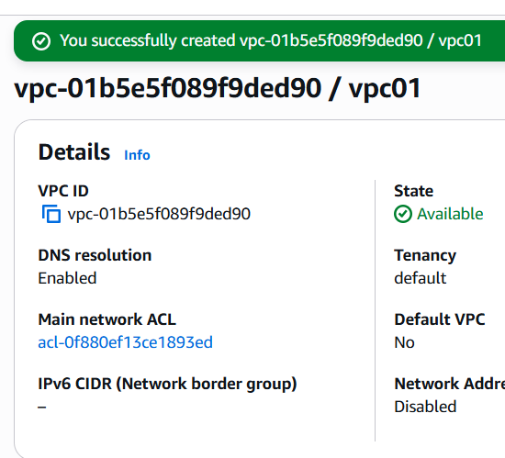
- Now select subnets
- Create subnets
- Subnet name , availability zone select us east a1
- Give ipv4 subnet cidr block
- As 11.0.0.0/28
- 2 public subnets
- Publicasub1-10.0.0./24
- Publicsub2-10.0.1.0/24
- 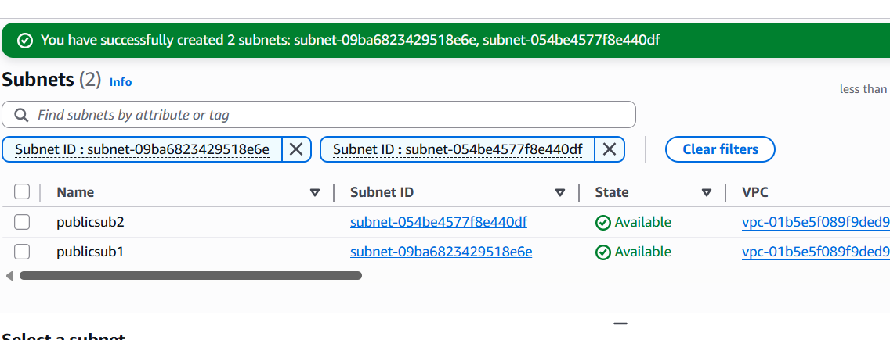
- 2 private subnets
- Privtesub1- 10.0.2.0/24
- Privatesub2-10.0.3.0/24
- 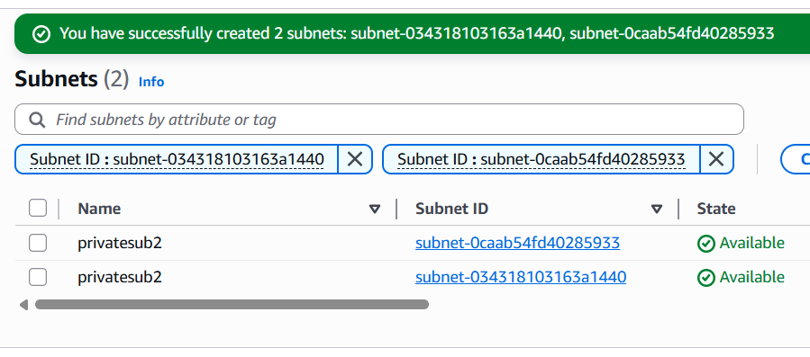
2. Enable DNS Hostname in VPC.
- Go to vpc page
- My vpc
- Select vpc and click actions hit edit vpc settings
- Enable dns resolution and enable dns hostnames in dns settings
- 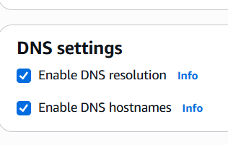
- 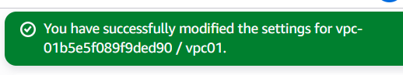
3 . Enable Auto Assign Public IP in 2 public subnets.
- Clicks subnets in vpc
- Select the publicsub1 and go to actions and click edit subnets settings
- 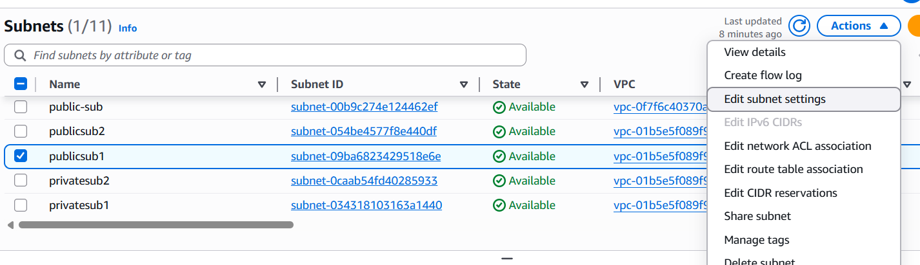
- Enable auto assign ip
- 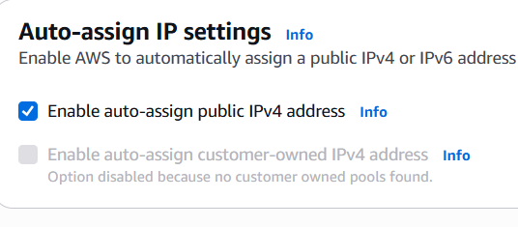
- Publicsubnet2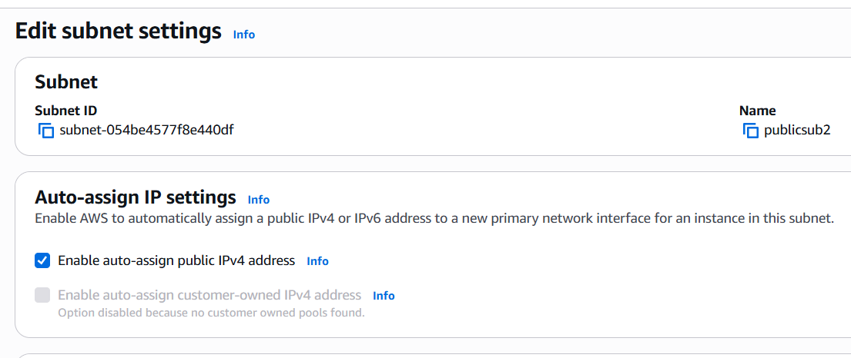

4. Add 2 private subnets in private route table.
- Go to vpc dashboard
- Navigate to routetable
- Create route table
- Add your vpc
- 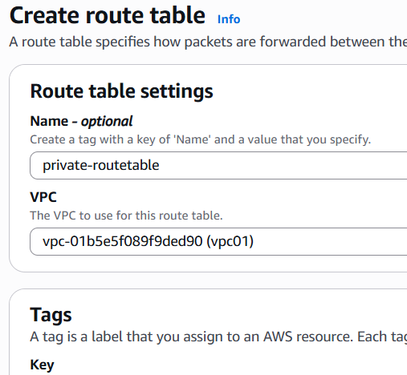
- Adding 2 private subnets in private routetable
- 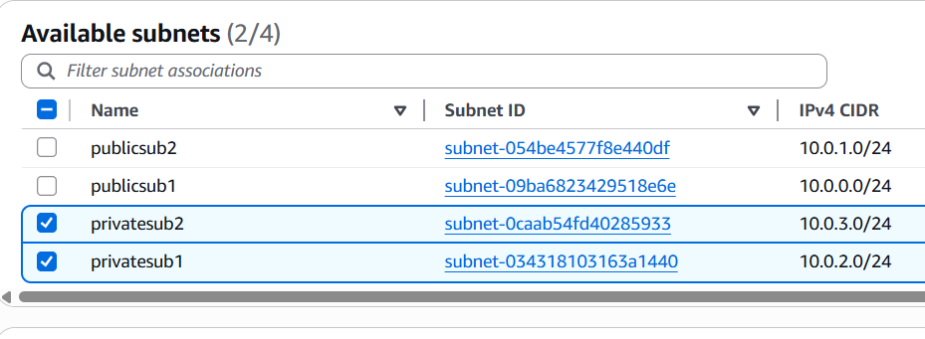

5. Add 2 public subnets in public route table.

- Creating one public rfoute table

- 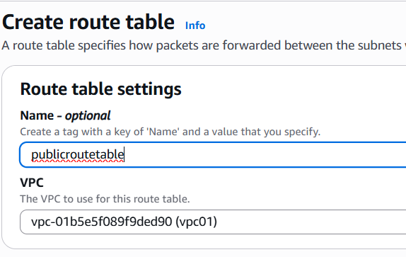
- Adding public subnets in public route table
- 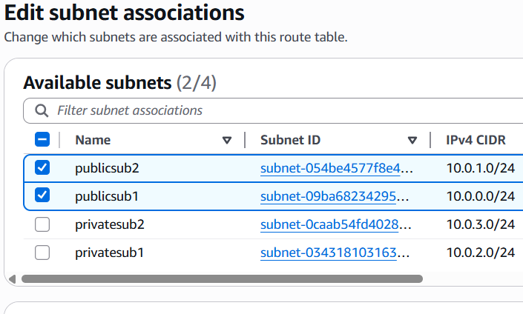

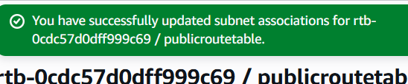
6. Public route table will have the routes to internet and local.

- Go to vpc dash board
- Select internet gateways
- Create internet gateway
- Now attach this internet gateway to VPC
- 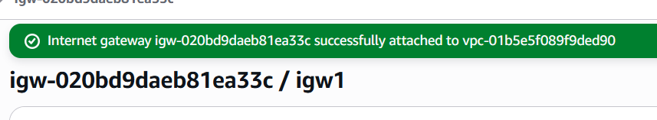
- Now, navigate to route table
- Select the table
- Now edit route table
- Add route
- Allow 0.0.0.0/0 and select created internetway
- \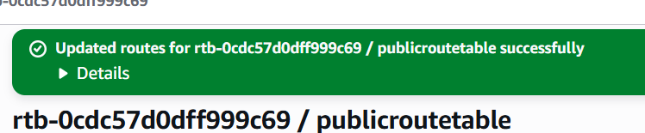

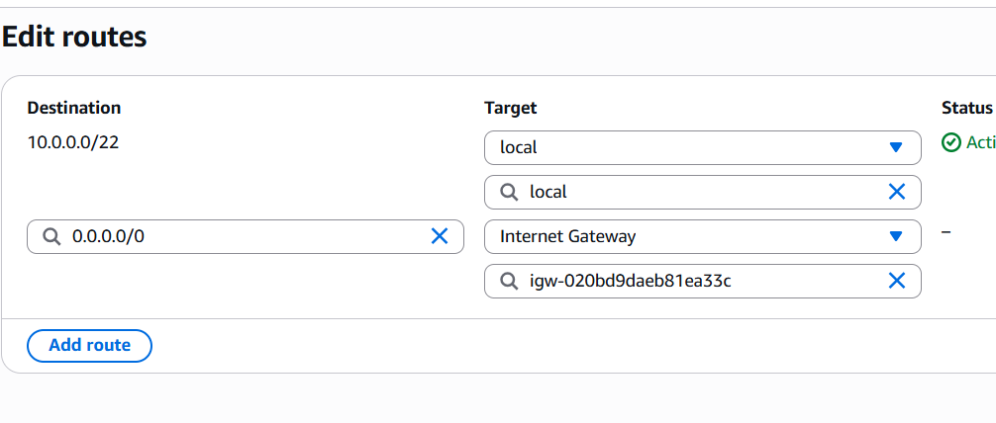
7. Create EC2 in public subnet with t2.micro and install PHP.
- Go to aws console
- Open ec2 service
- Launch an instance with created vpc
- Add public subnet
- Enable public ip
- Default security groups
- 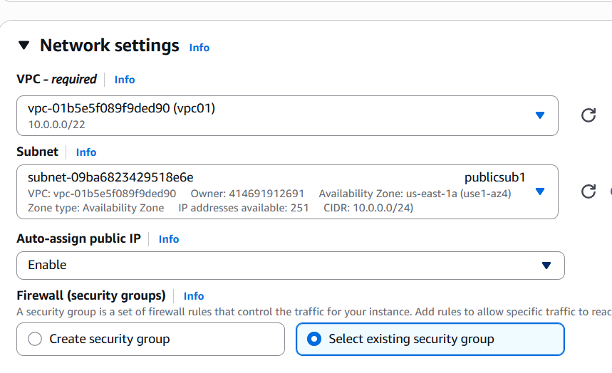
- Launch an instance
- Add port ssh 22 in security groups , inbound rules
- 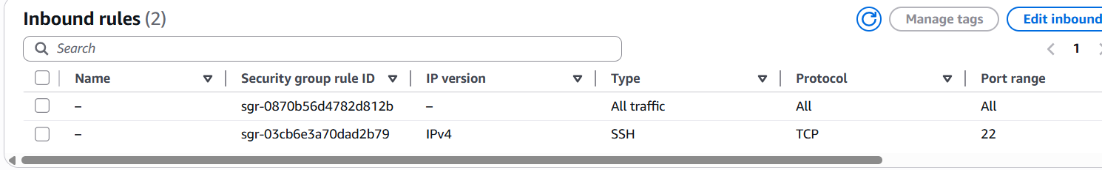
- Connect to instance using pemkey
- 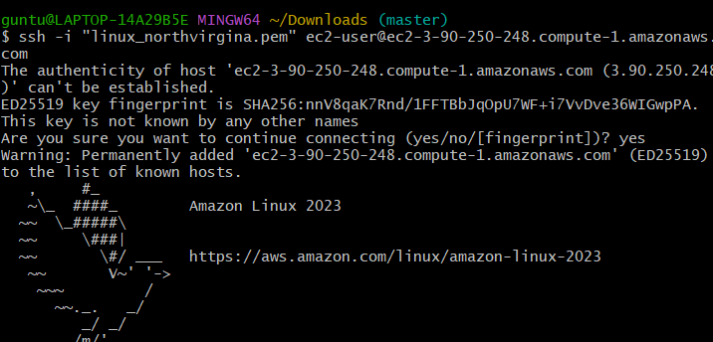
- Install php
- 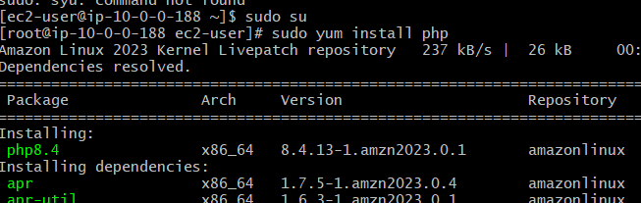
- For php we need to install httpd because, httpd is webserver,
- To see in web page , httpd is needed
- Php alone cant be seen
- Now
- # Enable PHP 8.2 (you can choose another version)
- sudo amazon-linux-extras enable php8.2

- # Install PHP and common extensions
- sudo yum install php-cli php-common php-mbstring -y

- # Restart Apache to apply PHP
- sudo systemctl restart httpd
- 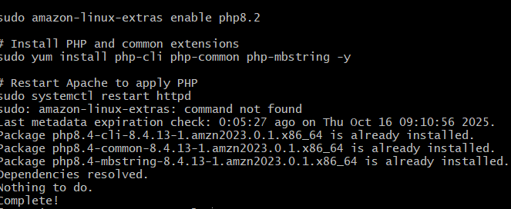
- Create a test page
- echo "<?php phpinfo(); ?>" | sudo tee /var/www/html/index.php
- 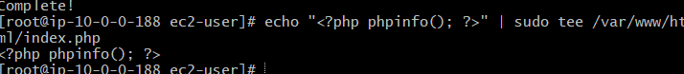
- Allow port 80 in bound rules
- Now verify in your browser
- http://(instance public ip)
- 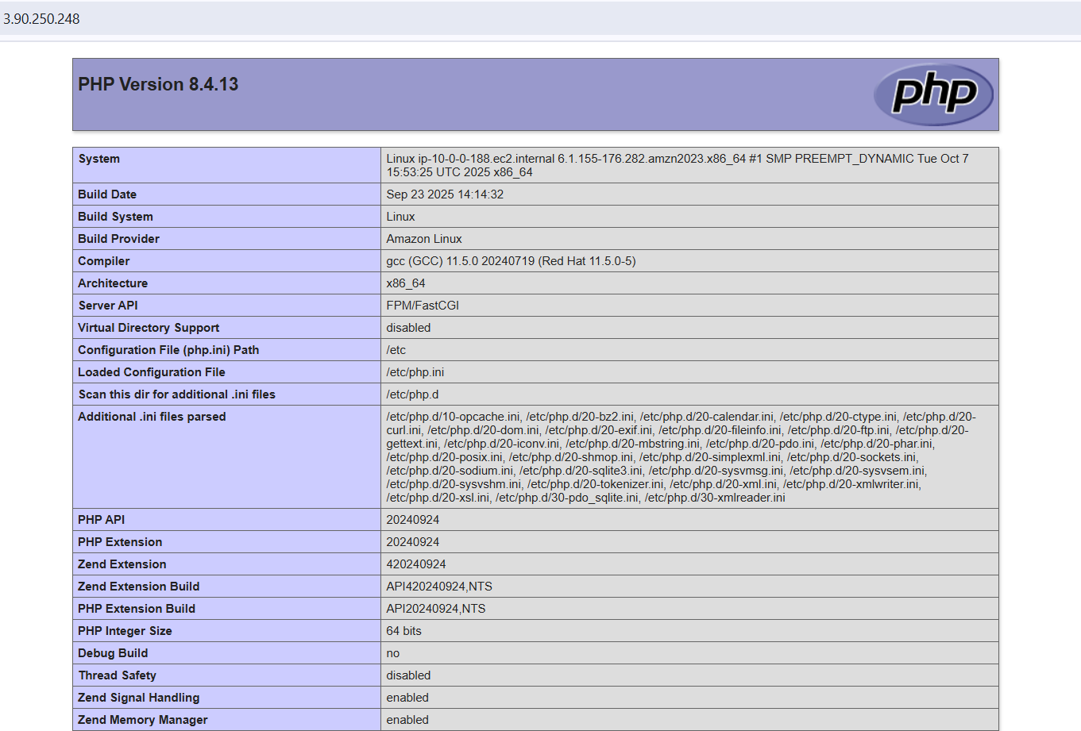
8. Configure NAT gateway in public subnet and connect to private instance
- Create a nat gateway
- Select public subnet
- Allocate elastic id
- Now go to route table
- Edit route table and add
- Add created nat gateway
- 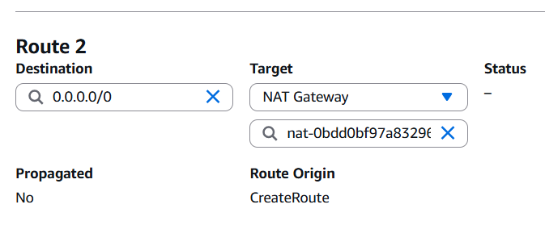
- 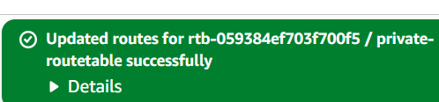
- Run public subnet instance
- Run private subnet instance
- Using pem.key connect to publicsubnet instasnce
- Now after connection has been established
- Enter private subnet instance pem.key in public.subnet instance
- 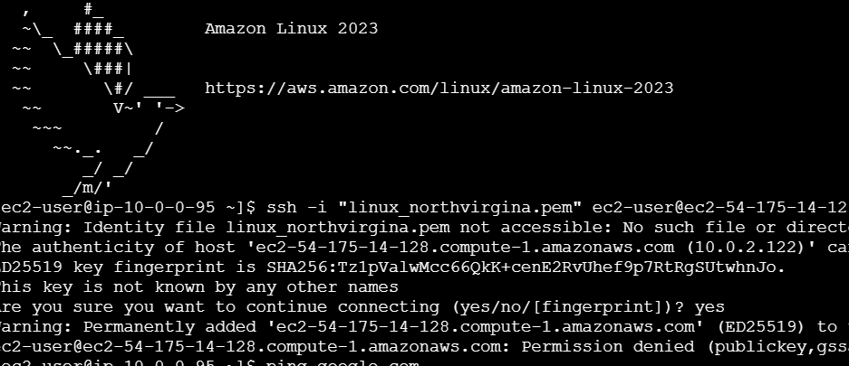
9 . Install Apache Tomcat in private EC2 and deploy a sample app
- Connect to amazon linux
- Download
- Apachetomcat
- Go to cd /opt/tomcat/bin
- Downloafd sample WAR file
- wget https://tomcat.apache.org/tomcat-10.1-doc/appdev/sample/sample.war

- 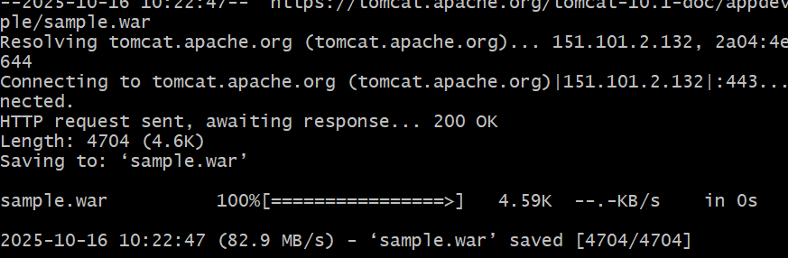

- Now deploy WAR file
- sudo cp sample.war /opt/tomcat/webapps/
- cd /opt/tomcat/bin
- ls
- 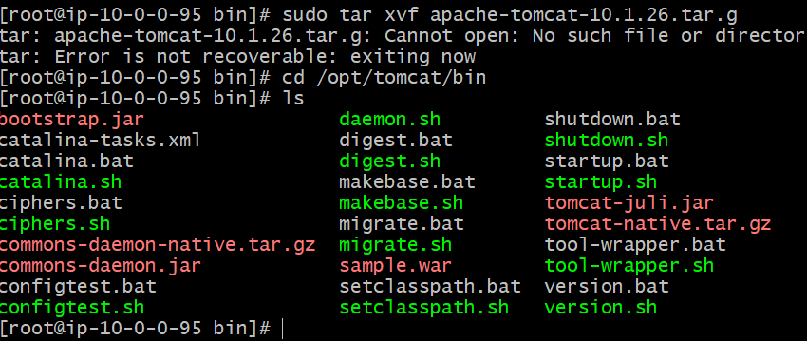

10.
- Go aws console
- Merge s3 bucket with vpc
- First create s3 bucket
- 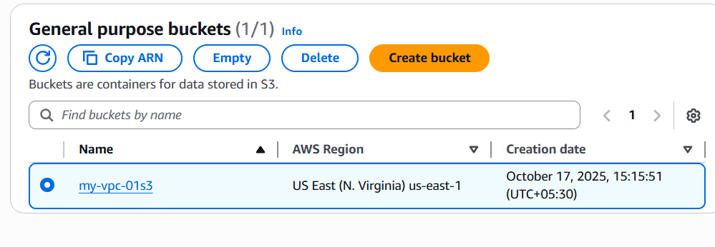
- Now select your vpc , click actions select create flow log

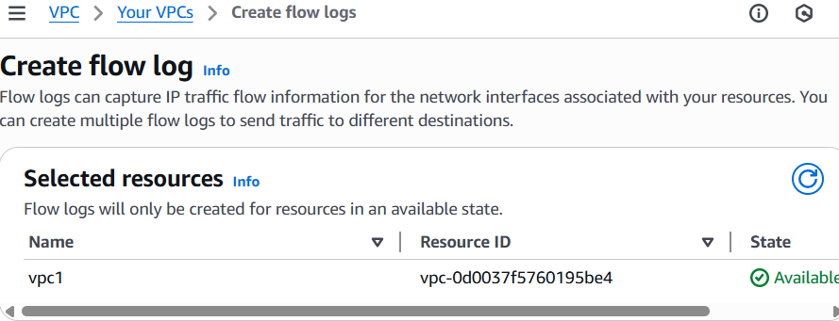
- Filter - all
- Copy s3 bucket arn and paste in flow log
- 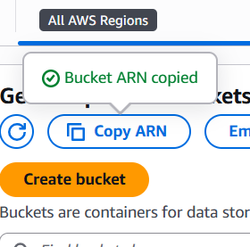
- Select option -send to amazon s3 bucket
- 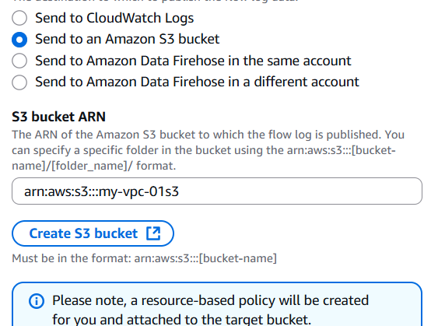
- Add text format
- Partition logs – every 24 hr
- Then create a flow log
- 